

SUMMER INTERNSHIP REPORT ON
DEVELOPMENT OF AN OCR-BASED DOCUMENT-TO-EXCEL UTILITY
SUBMITTED TO:
MANOJ KUMAR
(Chief Manager-TTI)
HINDUSTAN AERONAUTICS LIMITED
(TRANSPORT AIRCRAFT DIVISION, KANPUR)

SUBMITTED BY:
AYUSHI SAHU (MMMUT, 2023041224)
KAVYANJALI SINGH (CU, 24BCS12308)
KRISH AWASTHI (AIT, 2305051530071)
RISHABH KUMAR (RU, 2301506025)
SANSKRITI SAHANI (CU, 24BAI70801)
SHIKHA SAHU (MMMUT, 2023041253)

IN FULFILLMENT OF THE SUMMER INTERNSHIP
TRAINING PERIOD: 8TH JUNE TO 4TH JULY, 2026

CERTIFICATE

This is to certify that the project titled "Development of an OCR-Based Document-to-Excel Utility" has been successfully carried out by the following B.Tech/B.E students during their internship at Hindustan Aeronautics Limited (HAL), Transport Aircraft Division (TAD), Kanpur, in partial fulfilment of the requirements for the award of the degree of Bachelor of Technology/Engineering.
The project was completed under my guidance and supervision during the internship period of 08 June 2026 to 04 July 2026. To the best of my knowledge, the work presented in this report is original and is a faithful record of the work carried out by the students. This work has not been submitted, either in part or in full, for the award of any other degree or diploma at any university or institution.

Submitted By :-
- AYUSHI SAHU (MMMUT, 2023041224)
- KAVYANJALI SINGH (CU, 24BCS12308)
- KRISH AWASTHI (AIT, 2305051530071)
- RISHABH KUMAR (RU, 2301506025)
- SANSKRITI SAHANI (CU, 24BAI70801)
- SHIKHA SAHU (MMMUT, 2023041253)

MR. MAHESH CHANDRA SRIVASTAVA
DATE-04/07/2026 CHIEF MANAGER(IT)
PLACE-KANPUR HAL TAD, KANPUR

ACKNOWLEDGEMENT

We would like to extend our sincere gratitude towards Mr. Manoj Kumar Yadav (Chief Manager TTI, HAL TAD Kanpur) for allowing us to carry out this summer training at HAL TAD Kanpur and for their patience, guidance, constant encouragement, moral support, keen interest and valuable suggestion during preparation of this internship report. The present dissertation entitled “Development of an OCR-Based Document-to-Excel Utility”. We would like to express our gratitude to all those who gave us the possibility to complete this training. I want to thank Hindustan Aeronautics Limited for giving us the permission to commence this training in the first instance, to do the necessary research work and to use Technical Departmental data. We would take this opportunity as a proud privilege to express our deep felt of gratitude to
Mr. Mahesh Chandra Srivastava (CM, HAL TAD Kanpur)
Mr. Anupam Chaturvedi (CM, HAL TAD Kanpur)
Mr. Rahul Chaudhary (CM, HAL TAD Kanpur)
Last but not the least, we also wish to acknowledge my indebtedness to the staff of H.A.L. without whose co-operation, this training would not have been successful.
NAME | INSTITUTION
- AYUSHI SAHU | MMMUT, GORAKHPUR
- KAVYANJALI SINGH | CHANDIGARH UNIVERSITY, MOHALI
- KRISH AWASTHI | ALLENHOUSE INSTITUTE OF TECHNOLOGY, KANPUR
- RISHABH KUMAR | RAMA UNIVERSITY, KANPUR
- SANSKRITI SAHANI | CHANDIGARH UNIVERSITY, MOHALI
- SHIKHA SAHU | MMMUT, GORAKHPUR

DECLARATION

We, the undersigned students of the Bachelor of Technology/Bachelor of Engineering programme, hereby declare that the project titled "Development of an OCR-Based Document-to-Excel Utility", submitted to Hindustan Aeronautics Limited (HAL), Transport Aircraft Division (TAD), Kanpur, Uttar Pradesh, in partial fulfilment of the requirements for the award of the degree of Bachelor of Technology/Engineering, is our original work.
We further declare that this project has not been submitted previously, either in whole or in part, for the award of any degree, diploma, or any other academic qualification at any university or institution. We also affirm that all sources of information and references used in the preparation of this report have been duly acknowledged wherever applicable.

AYUSHI SAHU (B.TECH, INFORMATION TECHNOLOGY)
KAVYANJALI SINGH (B.E, CSE)
KRISH AWASTHI (B.TECH, CSE – AI&ML)
RISHABH KUMAR (B.TECH, CSE)
SANSKRITI SAHANI (B.E, CSE – AI&ML)
SHIKHA SAHU (B.TECH, ECE – INTERNET OF THINGS)

ABSTRACT

This internship report presents the development of a software utility for capturing and transferring data from physical documents and forms into Microsoft Excel. The project was carried out during a four-week internship at Hindustan Aeronautics Limited (HAL), Transport Aircraft Division (TAD), Kanpur, with the objective of reducing manual data entry efforts, improving data accuracy, and increasing operational efficiency.
The utility was designed to automate the process of extracting information from scanned documents or images using Optical Character Recognition (OCR) techniques and organizing the extracted data into a structured Excel format. The project involved studying existing document-processing workflows, identifying challenges associated with manual data entry, designing an efficient data extraction pipeline, and implementing validation mechanisms to improve the accuracy of the captured information.
Throughout the internship, practical exposure was gained in document digitization, OCR-based text extraction, image preprocessing, data parsing, error handling, and Excel automation. The project emphasized developing a user-friendly and reliable solution capable of processing different types of physical forms while minimizing human intervention.
The internship provided valuable experience in software development, automation, and real-world problem solving within an industrial environment. This report summarizes the project methodology, implementation process, key features, challenges encountered, and the overall outcomes achieved during the internship, highlighting the practical application of information technology in improving organizational productivity.

TABLE OF CONTENT

CERTIFICATE i
ACKNOWLEDGEMENT ii
DECLARATION iii
ABSTRACT iv
HAL HISTORY 1
HAL KANPUR (TAD DIVISION) 2

1. INTRODUCTION 3
1.1 About 3
1.2 Project Overview 4
1.3 Importance of Document Digitization and Automation 10
1.4 Scope of the Project 11

2. PROBLEM STATEMENT 12
2.1 Challenges in Manual Data Entry 12
2.2 Limitations of Existing Process 13
2.3 Need for Automated Solution 14

3. SOLUTION PROPOSED 15
3.1 Overview of the Utility 15
3.2 Working Principle 16
3.3 Key Features 17
3.4 Advantages 18

4. METHODOLOGY 19
4.1 System Workflow 19
4.2 OCR Processing Pipeline 20
4.3 Data Validation and Excel Generation 21
5. TOOLS AND TECHNOLOGIES USED 23
5.1 Python Programming Language 23
5.2 Streamlit Framework 24
5.3 OCR Technologies (EasyOCR & TrOCR) 24
5.4 Image Processing (OpenCV & PIL) 25
5.5 Data Handling (NumPy & Pandas) 25
5.6 Excel Generation (OpenPyXL) 26
5.7 Transformers (Hugging Face) 26
5.8 Development Environment (VS Code) 27

6. WORKING CODE & INPUT 28
6.1 Streamlit UI 28
6.2 OCR Implementation 29
6.3 TrOCR Module 30
6.4 Data Cleaning 31
6.5 Excel Generation 32
6.6 Template System 33

7. OUTPUT AND RESULTS 34
7.1 Application Interface 34
7.2 Template Management 35
7.3 Image Upload 36
7.4 OCR Output 37
7.5 Editable Results 38
7.6 Excel Output 39
7.7 Debug Section 40

8. CONCLUSION 41
8.1 Project Summary 41
8.2 Skills Gained 42
8.3 Future Enhancements 43

REFERENCES 44

HAL HISTORY

Establishment and Early Years
- Founded: 23 December 1940 as Hindustan Aircraft Limited in Bangalore by Shri Walchand Hira Chand.
- Initial Collaboration: With Inter Continental Aircraft Co. (USA) – manufactured Harlow Trainer, Curtiss Hawk, Vultee Bomber.
- 1942: Taken over by Government of India.
- 1951: Brought under Ministry of Defence.

Key Aircraft Developments (1950s–1970s)
- HT-2 Trainer (1951): First indigenous aircraft.
- Other Indigenous Aircraft: Pushpak – For flying clubs, Krishak – AOP role.
HF-24 Marut – Jet fighter, Kiran – Basic Jet Trainer.
- 1964: Merged with Aeronautics India Limited → Renamed as Hindustan Aeronautics Limited (HAL).
- Licensed production of aircraft: Vampire, Gnat, MiG-21, Jaguar, etc.

Helicopter Programs
- 1970: Helicopter Division (Bangalore) for Chetak & Cheetah (under French license).
- Later expanded to ALH Dhruv, LCH, LUH.
- 2006: ALH MRO Division created in Bangalore.
- Tuma kuru Facility (2016): For LUH manufacturing.
- Aircraft Instruments (Lucknow).
- Avionics & Electronics (Hyderabad, Korwa).
- Accessories (undercarriage, hydraulics, air-conditioning, etc.).

Space Program Contributions
- 1988: Aerospace Division formed.
- Supplies structures for ISRO’s
- PSLV, GSLV Mk III, Mars Orbiter, Human Spaceflight, Cryogenic engines.

Gas Turbines & Marine Applications
• 1998: Industrial & Marine Gas Turbine Division.
- Produces and overhauls LM-2500, Avon, Allison engines.
- Serves ONGC, GAIL, TNEB, etc.

R&D Infrastructure
• 10 R&D Centres across India focusing on:
- Fixed Wing Aircraft (LCA, IJT, HTT-40)
- Rotary Wing (LCH, LUH, IMRH)
- Mission Systems & Upgrades
- Aero Engines (HTFE-25, HTSE-1200)
- Avionics & Electronics
- Transport Aircraft
- Russian Aircraft Upgrades
- Mechanical & Hydraulic Accessories
- Materials & Processes

Display Systems & Data Recorders Current Manufacturing Programs (as of 2020)
- Aircraft: SU-30 MKI, LCA Tejas, Do-228.
- Helicopters: ALH Dhruv, LCH, LUH, Chetak, Cheetal.

Repair & Overhaul (ROH)
- Fighters: MiG-21, Su-30, Jaguar, Mirage.
- Trainers: Kiran.
- Transports: HS-748, AN-32, Do-228.
- Helicopters: Chetak, Cheetah, Cheetal, ALH.

Exports & Global Partnerships
- Exported: Dhruv, Chetak, Cheetah, Do-228.
- Partners: Airbus, Boeing, Rolls Royce, IAI, Rosoboronexport.

HISTORY OF HAL – (TAD), KANPUR

The Transport Aircraft Division (TAD) of Hindustan Aeronautics Limited (HAL), located in Kanpur, was established in 1960 to undertake licensed production of the HS-748 Avro turboprop aircraft from Hawker Sidley, UK. Strategically situated at a shared civil-military airfield, TAD originated from an Indian Air Force depot, laying a strong foundation in military aviation support.
In 1964, HAL was restructured through the merger of Hindustan Aircraft Limited, Aeronautics India Ltd., and the Kanpur IAF depot, bringing TAD formally under the HAL umbrella. Since its inception, the division has played a vital role in India's aviation ecosystem, supporting both defence and civil aviation sectors. Over the years, TAD Kanpur has delivered:
- 89 HS-748 Avro aircraft (1960–1983)
- 164 Basant agricultural gliders (1963–1986)
- 125+ Dornier 228 aircraft (from 1985 onwards)
In addition to manufacturing, the division has developed comprehensive capabilities for depot level overhaul and modernization of various aircraft, including HS-748, Dornier 228, AN-32, Canberra, and UAV systems. It is equipped with advanced infrastructure, including composite fabrication units, CNC machining, paint shops, and over 73,500 m² of hangar space. Since the 1980s, TAD has also undertaken avionics upgrades, systems integration, and modernization programs. It now produces the Hindustan-228, a civil-certified version of the Dornier 228, supporting the Government of India’s UDAN regional connectivity scheme through leasing to Alliance Air.
TAD maintains active R&D collaborations with institutions like IIT Kanpur, IIT Madras, and XTIC, focusing on aviation innovation, VR-based training, and special missions such as cloudseeding. A dedicated Technical Training Institute provides in-plant and apprentice training to engineering students and HAL trainees.
Today, with a workforce of over 2,200 personnel, TAD Kanpur continues to be a key contributor to India’s aerospace self-reliance through aircraft manufacturing, overhaul, civil aviation support, and skill development.

INTRODUCTION

1.1 About
In the digital age, organizations generate and manage a large amount of information through physical documents such as employee records, medical forms, registration forms, application forms, and surveys. Although these documents are convenient for collecting information, manually transferring the data into digital systems is a repetitive and time-consuming process. Manual data entry also increases the possibility of errors, leading to inaccurate records and reduced efficiency.
Document digitization helps overcome these challenges by converting information from physical documents into digital formats that can be easily stored, searched, and processed. One of the most widely used technologies for document digitization is Optical Character Recognition (OCR), which enables computers to recognize text from scanned documents or images. When combined with image processing and machine learning techniques, OCR provides an efficient solution for automating data extraction and reducing human effort.

1.2 Project Overview
The project, "Development of an OCR-Based Document-to-Excel Utility" aims to automate the process of extracting information from structured forms and storing it in Microsoft Excel.
The developed utility is built using Python and provides a user-friendly interface through the Streamlit framework. It accepts scanned images or photographs of forms as input and extracts textual information using EasyOCR. To improve the recognition of handwritten entries, the system also integrates TrOCR, a transformer-based handwriting recognition model.
The application supports dynamic form templates, allowing users to create, edit, and manage different document layouts. After extracting the required information, users can review and edit the detected values before exporting the final data into a professionally formatted Excel sheet.

1.3 Importance of Document Digitization and Automation
Many organizations still rely on manual data entry for processing information collected through physical forms. This approach is slow, requires significant human effort, and is susceptible to typing mistakes and inconsistencies. As the volume of documents increases, manual processing becomes increasingly difficult to manage.
Automating the document processing workflow offers several advantages. It reduces processing time, minimizes human errors, improves data accuracy, and enables faster access to digital records. OCR-based automation also enhances productivity by eliminating repetitive tasks and allowing employees to focus on more important responsibilities. The integration of modern OCR technologies with intelligent data processing has made automated document digitization a practical solution for various industries.

1.4 Scope of the Project
The scope of this project is to develop an efficient utility capable of extracting information from structured physical forms and generating organized Excel sheets automatically. The system supports multiple document templates, enabling it to process different types of forms without modifying the application code.
The utility includes features such as image upload, OCR-based text extraction, handwritten text recognition, template validation, editable extraction results, and Excel generation. It provides an easy-to-use interface that simplifies the entire document digitization process while improving both speed and accuracy.
The developed solution demonstrates how OCR, image processing, and automation technologies can be integrated to reduce manual effort and improve the efficiency of data management systems.

PROBLEM STATEMENT

2.1 Challenges in Manual Data Entry
Many organizations continue to rely on physical documents and forms to collect information such as employee details, medical records, registration data, and customer information. The information from these documents is often transferred manually into digital systems or spreadsheets. Although this method is straightforward, it is time-consuming and requires significant human effort, especially when handling a large number of documents.
Manual data entry is also repetitive in nature, which increases the chances of typing mistakes, missing values, duplicate entries, and inconsistencies in the stored data. Such errors can affect the accuracy of records and may require additional time for verification and correction. As the volume of documents increases, managing and organizing information manually becomes increasingly inefficient.

2.2 Limitations of Existing Process
Traditional document processing methods involve reading each form individually and entering the required information into an Excel sheet or database. This approach has several limitations:
- It requires continuous human involvement for every document.
- Processing large number of forms consumes considerable time.
- Handwritten information can be difficult to interpret consistently.
- Manual typing may introduce spelling mistakes and incorrect data.
- Verifying and correcting errors further increases processing time.
- The process is not suitable for organizations handling large-scale documentation on the daily basis.
These limitations highlight the need for an efficient and automated solution capable of reducing manual effort while maintaining data accuracy.

2.3 Need for an Automated Solution
To overcome the challenges of manual document processing, an intelligent utility is required that can automatically extract information from structured forms and convert it into a digital format. Such a system should minimize human intervention while providing accurate and reliable results.
The developed utility addresses this requirement by using OCR technology to recognize text from scanned documents and images. It combines EasyOCR for text detection with TrOCR for improved handwritten text recognition. The application also supports dynamic form templates, enabling it to process different document formats without requiring changes to the program.
After extracting the information, the system allows users to review and edit the detected values before generating a structured Microsoft Excel sheet. This approach significantly reduces processing time, improves accuracy, and simplifies document digitization.
The project aims to provide a practical and user-friendly solution that enhances productivity by automating repetitive data entry tasks while ensuring that the extracted information is organized and readily available for further use.

SOLUTION PROPOSED

3.1 Overview of the Developed Utility
To address the challenges associated with manual data entry, an automated utility named "Development of an OCR-Based Document-to-Excel Utility" was developed. The application is designed to extract information from structured physical forms and automatically organize the extracted data into a Microsoft Excel sheet.
The utility is developed using the Python programming language and provides a simple, interactive interface through the Streamlit framework. Users can upload an image of a structured form, select the appropriate template, and initiate the extraction process with a single click. The system processes the uploaded document, recognizes the required information, and presents the extracted data for review before generating the final Excel file.
The application is designed to work with multiple structured document formats through a dynamic template management system, making it flexible and easy to adapt to different use cases.

3.2 Working Principle of the Utility
The utility follows a systematic approach to convert information from physical documents into structured digital data. Once an image is uploaded, the system performs Optical Character Recognition (OCR) using EasyOCR to detect text from the document. For improved recognition of handwritten values, the application utilizes TrOCR, which provides better accuracy for handwritten text.
After text extraction, the application validates the uploaded document against the selected template to ensure that the correct form is being processed. The extracted information is then cleaned and organized according to the predefined fields of the selected template.
The application also allows users to review and edit the extracted values before exporting the final output. Once verified, the processed data is automatically saved in a professionally formatted Microsoft Excel worksheet, making it ready for storage, reporting, or further analysis.

3.3 Key Features of the Solution
The developed utility includes several features that improve the efficiency and accuracy of document digitization:
- User-friendly web interface developed using Streamlit.
- Upload and process scanned images in JPG and PNG formats.
- Automatic text extraction using EasyOCR.
- Improved handwritten text recognition using TrOCR.
- Dynamic creation, editing, and deletion of form templates.
- Template validation to ensure the correct document type is processed.
- Automatic mapping of extracted values to predefined fields.
- Post-processing and cleaning of extracted text.
- Manual correction of OCR results before final export.
- Generation of well-formatted Microsoft Excel sheets.
- Local storage of custom templates using JSON configuration files.
- Adjustable OCR confidence threshold for improved extraction performance.
- Debug panel for viewing detected and skipped text elements.

3.4 Advantages of the Proposed Solution
The developed utility offers several advantages over conventional manual data entry methods. It significantly reduces the time required to process structured forms while minimizing human errors during data transcription. The dynamic template management feature enables the application to support multiple document layouts without modifying the program code, making it highly flexible and reusable.
The integration of EasyOCR and TrOCR improves the recognition of both printed and handwritten text, resulting in better extraction accuracy. Additionally, the option to review and edit extracted information before generating the Excel sheet ensures greater reliability of the final output.
Overall, the proposed solution provides a practical, efficient, and scalable approach for digitizing structured physical documents. It simplifies document processing, improves productivity, and supports organizations in their transition toward automated digital record management.

METHODOLOGY

4.1 System Workflow
The developed utility follows a systematic workflow to automate the extraction of information from structured physical forms. The process begins with uploading an image of the document through the Streamlit-based user interface. The uploaded image is then processed to detect and recognize textual information using Optical Character Recognition (OCR).
The extracted text undergoes validation and cleaning before being mapped to the predefined fields of the selected template. The application also allows users to review and modify the extracted values if necessary. Finally, the verified information is exported into a formatted Microsoft Excel sheet, which can be downloaded directly from the application.
This workflow ensures that the entire document digitization process is performed efficiently while maintaining accuracy and minimizing manual efforts.

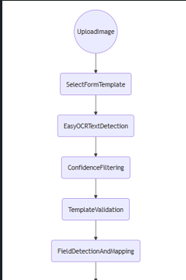
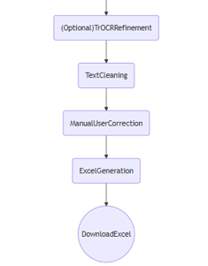

4.2 OCR Processing Pipeline
The core of the system is based on a hybrid OCR pipeline using EasyOCR and TrOCR.
- EasyOCR is used for initial text detection from the uploaded image.
- The detected text is filtered based on confidence score to remove low-quality predictions.
- The system identifies structured regions (labels and corresponding values) using positional analysis.
- For improved accuracy in handwritten text, TrOCR (Transformer OCR) is optionally applied on cropped regions.
Additionally, the system uses image coordinate grouping logic to merge nearby text into meaningful rows, ensuring proper field-value extraction from structured forms.

4.3 Data Validation and Excel Generation
After OCR processing, the extracted text is validated using the selected template. Each template contains predefined field names and skip keywords that help identify irrelevant or header text.
- Removes irrelevant headers and noise text.
- Matches extracted values with expected form fields.
- Cleans text using rule-based formatting (email, DOB, numeric fields).
- Allows manual correction of extracted values through the UI.
Once validation is completed, the cleaned data is passed to the Excel generation module. The system uses OpenPyXL to create a structured Excel sheet with proper formatting, including headers, borders, and alignment. The final file is made available for download directly from the Streamlit interface.

TOOLS & TECHNOLOGIES USED

5.1 Programming Language – Python
The entire system is developed using Python, a high-level programming language widely used for automation, artificial intelligence, and data processing applications. Python provides simplicity, rich libraries, and strong community support, making it suitable for OCR-based and image processing projects.
In this project, Python is used to integrate OCR models, handle image processing, manage data flow, and generate Excel files.

5.2 Streamlit Framework
The user interface of the application is built using Streamlit, an open-source Python framework used for creating interactive web applications.
Streamlit allows rapid development of UI components such as:
- File upload system
- Buttons and sliders
- Data display tables
- Real-time interaction
It helps in converting the Python script into a user-friendly web application without requiring frontend development.

5.3 OCR Technologies

EasyOCR
EasyOCR is used for detecting printed text from images. It provides bounding box detection and confidence scores, which are used for filtering and processing text efficiently.

TrOCR (Transformer OCR)
TrOCR, developed using transformer-based architecture, is used for recognizing handwritten text. It improves accuracy when processing non-printed or unclear text regions in documents.
The combination of EasyOCR and TrOCR improves overall extraction performance.

5.4 Image Processing Libraries

OpenCV
OpenCV is used for image preprocessing tasks such as:
- Image conversion
- Coordinate extraction
- Region segmentation
- Spatial analysis of text
Pillow (PIL)
Pillow is used for handling image files and converting uploaded images into formats suitable for OCR processing.

5.5 Data Processing Libraries

NumPy
NumPy is used for handling image arrays and performing numerical operations on pixel data.

Pandas
Pandas can be used for organizing extracted data into structured tabular format before exporting to Excel.

5.6 Excel Generation

OpenPyXL
OpenPyXL is used to create and format Excel files (.xlsx). It allows:
- Writing structured data into sheets
- Applying styling (fonts, borders, colors)
- Formatting headers and cells
The final extracted data is exported using this library.

5.7 Model Framework

Hugging Face Transformers
The TrOCR model is loaded using the Transformers library by Hugging Face, which provides pre-trained deep learning models for text recognition tasks.

5.8 Development Environment
- IDE: Visual Studio Code (VS Code)
- Language Runtime: Python 3.x
- Execution Platform: Local system (offline processing supported for TrOCR)

WORKING CODE & INPUT

6.1 Streamlit User Interface
The user interface is developed using Streamlit, which allows uploading images, selecting templates, and controlling OCR settings.

Key Code Snippet:
st.set_page_config(page_title="Form OCR → Excel", layout="wide")
st.title("Form OCR → Excel")
uploaded = st.file_uploader("Upload Image", type=["jpg", "png", "jpeg"])
use_trocr = st.toggle("Use TrOCR (Accurate, Slower)")
run_btn = st.button("Extract Content")

Explanation:
This section creates the web interface of the application. It allows users to upload form images, enable TrOCR mode, and start the extraction process using a button.

6.2 OCR Processing using EasyOCR
EasyOCR is used for detecting text from images along with confidence scores.

Key Code Snippet:
reader = easyocr.Reader(["en"], gpu=False)
results = reader.readtext(img_array, detail=1)
results = [r for r in results if r[2] >= conf_thresh]

Explanation:
- The OCR model reads text from the image.
- Each detection includes text, bounding box, and confidence score.
- Low-confidence results are filtered to improve accuracy.

6.3 Handwritten Text Recognition (TrOCR)
TrOCR is used for improving recognition of handwritten or unclear text.

Key Code Snippet:
processor = TrOCRProcessor.from_pretrained(local_path)
model = VisionEncoderDecoderModel.from_pretrained(local_path)
pixel_values = processor(images=crop_pil, return_tensors="pt").pixel_values
ids = model.generate(pixel_values)
text = processor.batch_decode(ids, skip_special_tokens=True)[0]

Explanation:
- Image crops are passed to the transformer model.
- The model predicts handwritten text.
- Output is decoded into readable text format.

6.4 Data Cleaning and Validation
After OCR, extracted text is cleaned and formatted based on field type.

Key Code Snippet:
def clean_extracted_text(field_name, text):
text = re.sub(r'\s+', ' ', text).strip()
if field_name == "Email":
text = text.lower().replace(" ", "")
elif field_name == "Date of Birth":
digits = re.sub(r'\D', '', text)
if len(digits) == 8:
text = f"{digits[:2]}/{digits[2:4]}/{digits[4:]}"
return text

Explanation:
- Removes extra spaces and noise.
- Formats email and date fields.
- Ensures structured and consistent output.

6.5 Excel File Generation
Final extracted data is exported into a formatted Excel sheet using OpenPyXL.

Key Code Snippet:
wb = openpyxl.Workbook()
ws = wb.active
ws.title = "Extracted Data"
ws["A1"] = "Field"
ws["B1"] = "Value"
for i, (k, v) in enumerate(data.items(), start=2):
ws.cell(row=i, column=1, value=k)
ws.cell(row=i, column=2, value=v)
wb.save("output.xlsx")

Explanation:
- Creates a new Excel workbook.
- Writes field names and extracted values.
- Saves structured output file for download.

6.6 Template-Based Processing Logic
The system supports multiple form templates to handle different document types.

Key Idea:
FIELDS = template["fields"]
SKIP_KEYWORDS = template["skip_keywords"]

Explanation:
- Each template defines expected fields.
- Skip keywords help ignore irrelevant text like headers.
- Enables multi-form support without code changes.

INPUT

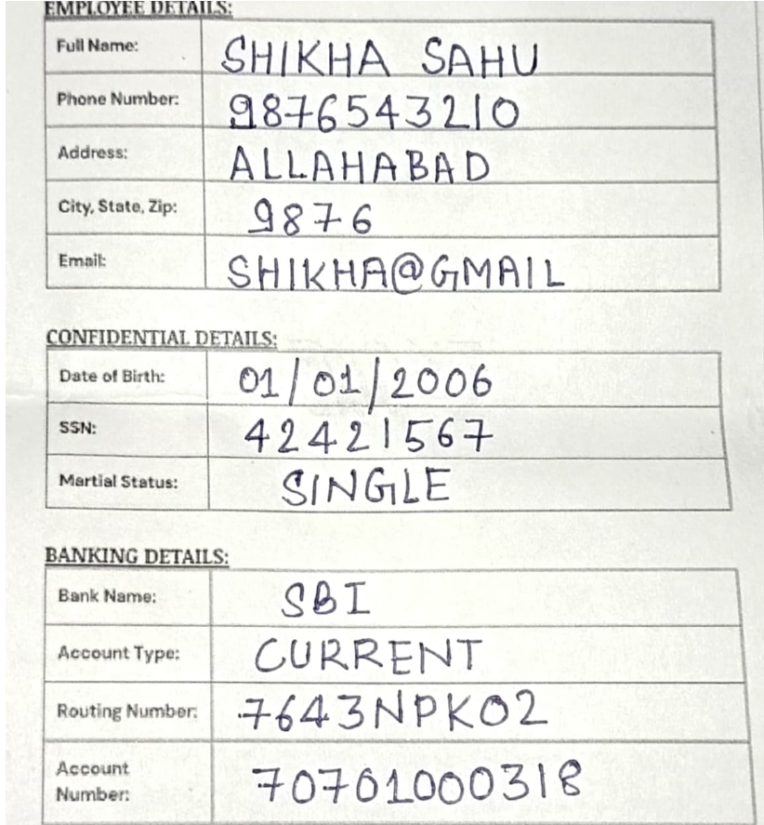

OUTPUT AND RESULTS

7.1 Application Home Interface
Streamlit Home Page (Upload + Template Selection UI)
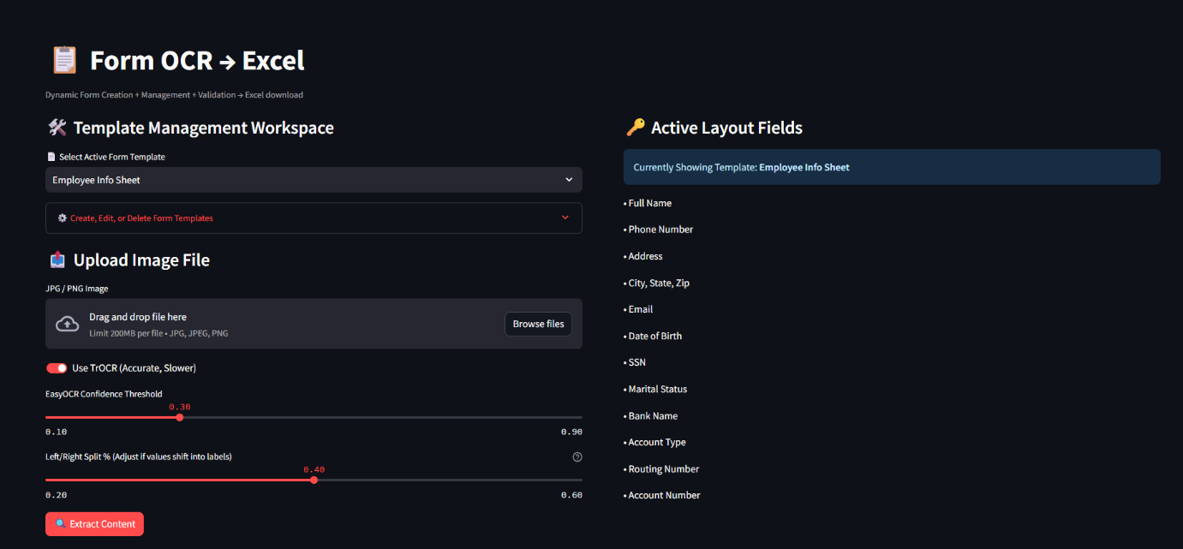
This screen shows the main interface of the application where the user can upload a document image, select a form template, and configure OCR settings before starting the extraction process
.7.2 Template Management System
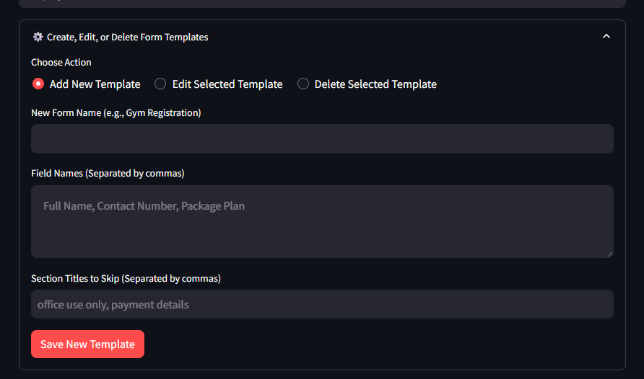

Text:
This section demonstrates the dynamic template management feature of the system, where users can create, modify, or delete form templates without changing the source code.

7.3 Image Upload and Processing
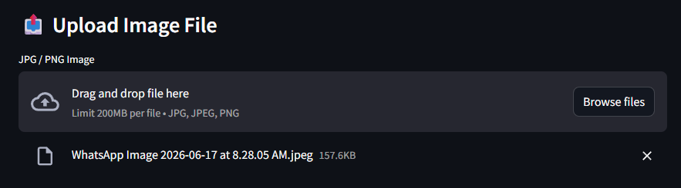
Uploaded Form Image Preview
Text:
This shows the uploaded physical document which will be processed using OCR techniques to extract structured data.

7.4 OCR Extraction Output
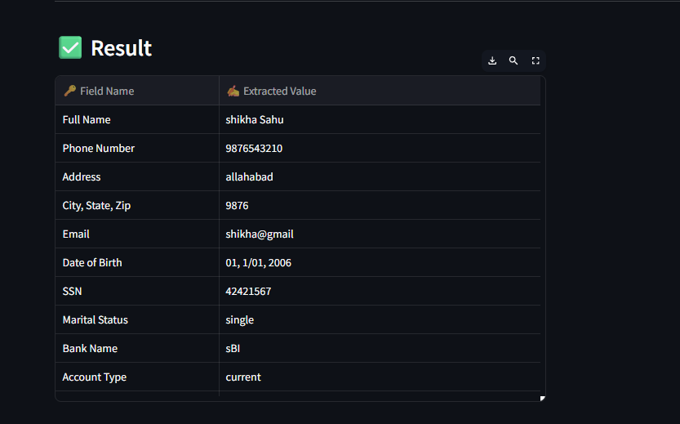
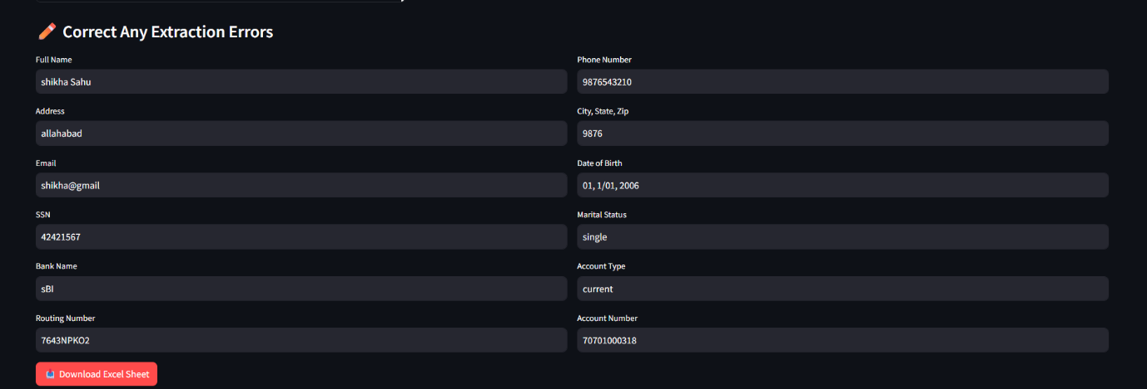

Excel Sheet

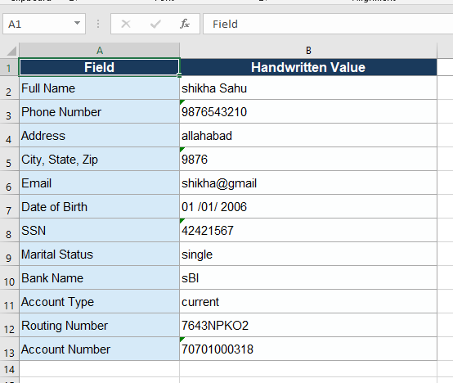

CONCLUSION

8.1 Project Summary
The project titled “Development of an OCR-Based Document-to-Excel Utility” was successfully developed to automate the process of extracting information from structured physical documents and converting it into a digital Excel format.
The system integrates Optical Character Recognition (OCR) using EasyOCR along with Transformer-based OCR (TrOCR) to improve the accuracy of text extraction, especially for handwritten content. The application is built using Python and Streamlit, providing an interactive and user-friendly interface for document processing.
The utility supports dynamic form templates, allowing users to define, edit, and manage multiple document formats without modifying the core code. It also includes validation, manual correction, and structured Excel generation features, making the system more reliable and practical for real-world usage.

8.2 Skills and Knowledge Gained
During the development of this project, several technical and practical skills were gained, including:
- Implementation of Optical Character Recognition (OCR) techniques
- Working with EasyOCR and Transformer-based models (TrOCR)
- Image processing using OpenCV and Pillow
- Web application development using Streamlit
- Data handling and manipulation using Python
- Excel file generation using OpenPyXL
- Understanding of real-world document digitization workflows
- Debugging, optimization, and system integration techniques
This project also improved problem-solving abilities and provided hands-on experience in building an end-to-end automation system.

8.3 Future Enhancements
Although the current system performs effectively for structured forms, several improvements can be implemented in the future to enhance its capabilities:
- Support for unstructured and complex document layouts
- Integration with cloud storage systems for remote access
- Database integration for large-scale data storage
- Improved handwritten recognition using advanced deep learning models
- Multi-language OCR support
- Automatic form detection without template selection
REFERENCE

[1] Streamlit Inc., "Streamlit: A Faster Way to Build and Share Data Apps," Version 1.35.0, 2024.
[2] Jaided AI, "EasyOCR: Ready-to-use Optical Character Recognition (OCR)," Version 1.7.2, 2024.
[3] Hugging Face Inc., "Transformers: State-of-the-Art Machine Learning for PyTorch, TensorFlow, and JAX," Version 4.38.2, 2024.
[4] PyTorch Contributors, "PyTorch: An Imperative Style, High-Performance Deep Learning Library," Version 2.1.2, 2023.
[5] Python Software Foundation, "Python Imaging Library (Pillow)," Version 10.4.0, 2024.
[6] NumPy Developers, "NumPy: The Fundamental Package for Scientific Computing with Python," Version 1.26.4, 2024.
[7] OpenPyXL Developers, "OpenPyXL: A Python Library to Read/Write Excel 2010 xlsx/xlsm Files," Version 3.1.2, 2024.
[8] Microsoft Corporation, "Visual Studio Code," Version 1.101, 2025.
[9] Microsoft Corporation, "Visual Studio Code Extensions Marketplace," Available: https://marketplace.visualstudio.com/. Accessed: Jul. 1, 2026.
[10] Ollama, "Ollama: Run Large Language Models Locally," Version 0.6.2, 2025. Available: https://ollama.com/. Accessed: Jul. 1, 2026.

